Report on ECDE Teachers in all wards in Makueni County and Type of School (2018–2022)
Introduction
This report presents an analysis of Early Childhood Development Education (ECDE) enrollment trends of all teachers in all wards in Makueni County in Public and Private Schools. The data encompasses both public and private schools across a five-year period (2018–2022). The purpose of this report is to examine total teachers enrollments, identify trends, and explore the relationship between public and private teachers enrollments in these wards.
Data Summary
The enrollment data was analyzed for both public and private ECDE centers, considering the following parameters:
Public enrollments from 2018 to 2022
Private enrollments from 2018 to 2022
Total enrollments, computed as the sum of public and private enrollments.
Proportions of Public vs. Private Enrollment
Overall, public enrollments far outnumber private enrollments across all wards. The proportions of public vs. private enrollment for all wards from 2018 to 2022 are as follows:
Public Enrollment: 85.29%
Private Enrollment: 14.71%
These figures underscore the dominance of public ECDE centers in all wards, with private enrollments contributing a smaller share of the total.
Visual Representation
Bar Plot: Public vs Private Enrollment by Ward (2018–2022)
The bar plot visually represents the distribution of public and private teachers enrollments across the all wards. Public enrollments far surpass private enrollments.
Pie Chart for Public vs Private teachers Enrollment in all wards (2018–2022)
The pie chart below highlights the overall dominance of public ECDE enrollments across all wards.
Correlation Analysis
Correlation between Public and Private Enrollment (2018–2022)
The correlation between public and private enrollments across the wards from 2018 to 2022 is -0.113, indicating a strong negative positive correlation. This suggests that, an increase in public teachers enrollments are not associated with an increase in private enrollments.
Scatter Plots
Scatter Plot: Public vs Private Enrollment This scatter plot shows a strong negative positive relationship between public and private enrollments, suggesting that increases in public teachers enrollment are not associated with increases in private enrollment.
Scatter Plot: Public vs Total teachers Enrollment This scatter plot illustrates that public enrollments significantly influence total enrollments, with the points closely aligned along the line, indicating a strong correlation.
Scatter Plot: Private vs Total teachers Enrollment The scatter plot displays a weaker correlation for private enrollments, indicating they contribute less significantly to the total enrollments compared to public enrollments.
RATIOS
Below ratios between public and private teachers in 2022
Also, the ratios between public and total in 2022
Ward Ratio_Public_Private_2022 Ratio_Public_Total_2022
1 Mbooni 19.000000 0.9500000
2 Tulimani 13.666667 0.9318182
3 Kithungo/Kitundu NA 1.0000000
4 Kalawa 7.800000 0.8863636
5 KaKo/Waia 12.800000 0.9275362
6 Kisau/Kiteta 7.923077 0.8879310
7 Mukaa/Kitaingo 33.500000 0.9710145
8 Kiimakiu/Kalanzoni 3.875000 0.7948718
9 Kasikeu 8.500000 0.8947368
10 Ukia 4.700000 0.8245614
11 Kilungu 3.315789 0.7682927
12 Ilima 34.000000 0.9714286
13 Kee NA 1.0000000
14 Wote,Nziu 1.000000 0.5000000
15 Muvau/Kikumini 4.833333 0.8285714
16 Kathonzweni 12.833333 0.9277108
17 Kitise/Kithuki 69.000000 0.9857143
18 Mbitini 9.000000 0.9000000
19 Nzaui/Kilili/Kalamba 8.900000 0.8989899
20 Mavindini 13.750000 0.9322034
21 Makindu 2.071429 0.6744186
22 Nguu/Masumba 6.700000 0.8701299
23 Emali/Mulala 2.666667 0.7272727
24 Nguumo 4.300000 0.8113208
25 Kikumbulyu North 5.000000 0.8333333
26 Kikumbulyu South 2.461538 0.7111111
27 Ivingoni/Nzambani 2.909091 0.7441860
28 Mtito Andei 2.818182 0.7380952
29 Thange 3.590909 0.7821782
30 Masongaleni 36.000000 0.9729730
Ratio_Private_Total_2022
1 0.05000000
2 0.06818182
3 0.00000000
4 0.11363636
5 0.07246377
6 0.11206897
7 0.02898551
8 0.20512821
9 0.10526316
10 0.17543860
11 0.23170732
12 0.02857143
13 0.00000000
14 0.50000000
15 0.17142857
16 0.07228916
17 0.01428571
18 0.10000000
19 0.10101010
20 0.06779661
21 0.32558140
22 0.12987013
23 0.27272727
24 0.18867925
25 0.16666667
26 0.28888889
27 0.25581395
28 0.26190476
29 0.21782178
30 0.02702703
Illustration:
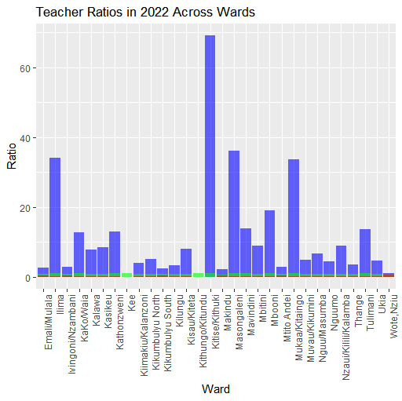
Conclusion
The analysis of ECD teachers enrollments in all wards reveals that public enrollments dominate across all wards, with private enrollments playing a smaller, though varying, role.The strong negative positive correlation between public and private enrollments suggests that an in increase in public teachers enrollment are not associated with private enrollment.

